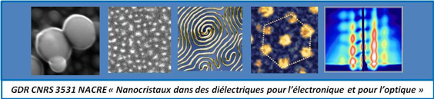
Abstract for GdR NACRE Plenary Meeting

Title (Calibri 14, Bold, blue color)
Author 1¹, author 2², etc. (Calibri 11, Bold, black)
- Affiliation 1 (calibri 10, black)
Laboratory Name, Department Name, Line research organization or University 1, Line research organization or University 2, etc., City, Country
- Affiliation 2

Abstract (no longer than 250 words (or 18 lines max. incl. figure), Calibri 11, single line spacing, black)

Keywords: (4-5 keywords are required)

References (max. 5):

Acknowledgment:

